ASSIGNMENT 2

i.Display the entire department information.

SELECT * FROM DEPARTMENT;

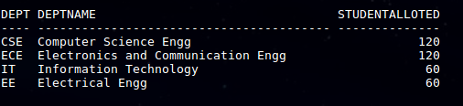

ii.Display the department with allotted student number more than 100.

SELECT * FROM DEPARTMENT WHERE STUDENTALLOTED>100;

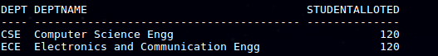

iii.Display all students’ detail of CSE.

SELECT * FROM STUDENT WHERE DEPTCODE='CSE';

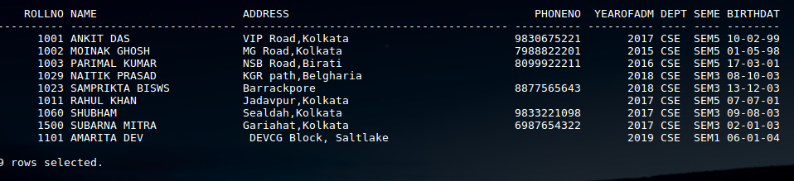

iv.Display students name along with department code and semester who

admitted in 2018.

SELECT NAME,DEPTCODE,SEMESTER FROM STUDENT WHERE YEAROFADM=2018;

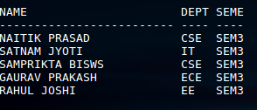

v.Show the name and semester of the CSE students who do not have phone

numbers.

SELECT NAME,SEMESTER FROM STUDENT WHERE DEPTCODE='CSE' AND PHONENO IS NULL;

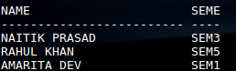

vi.Show name and phone numbers students whose name starts with ‘R’.

SELECT NAME,PHONENO FROM STUDENT WHERE NAME LIKE 'R%';

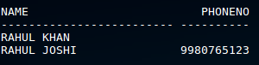

vii.Show name and phone numbers students with Surname ‘Kumar’.

SELECT NAME,PHONENO FROM STUDENT WHERE NAME LIKE '%KUMAR';

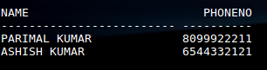

viii.Show name, year of admission, deptcode of the student with second

alphabet of name is ‘A’.

Select name,yearofadm,deptcode from student where name like '_A%';

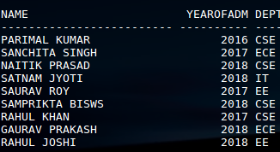

ix.Show student details of CSE resident of KOLKATA, who born before

2000.

SELECT * FROM STUDENT WHERE ADDRESS LIKE '%Kolkata' and deptcode='CSE' and BIRTHDATE < '01-01-00';



x.Show student details of 2 nd year who born in first day of a month.

SELECT * FROM STUDENT WHERE SEMESTER=‘SEM3’ AND SEMESTER=’SEM4’ AND BIRTHDATE LIKE ‘01%’;



xi.Display the students list of IT department who resides in ‘KOLKATA’

and admitted in 2017.

SELECT * FROM STUDENT WHERE DEPTCODE=’IT’ AND ADDRESS LIKE ‘%Kolkata’ AND YEAROFADM=2017;



xii.Show the phone no, year of admission and birth date of CSE students

born in ‘JUNE’.

SELECT PHONENO,YEAROFADM,BIRTHDATE FROM STUDENT WHERE BIRTHDATE LIKE '___06%';



xiii.Display the list of ECE 3 rd year students whose birthday is 20 th October.

SELECT * FROM STUDENT WHERE DEPTCODE='ECE' AND (SEMESTER='SEM5' OR SEMESTER='SEM6') AND BIRTHDATE LIKE '20-10%';



xiv.Show student details who born in either May, June, September or

December.

SELECT * FROM STUDENT WHERE BIRTHDATE LIKE '___05%' OR BIRTHDATE LIKE '___06%' OR BIRTHDATE LIKE '___09%' OR BIRTHDATE LIKE '___12%';

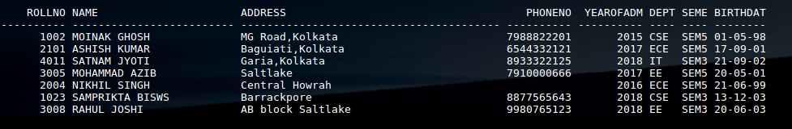

IV.Display the students name, department, semester whose age is more than 20

Year.

SELECT NAME,DEPTCODE,SEMESTER FROM STUDENT WHERE BIRTHDATE < '01-01-00';

